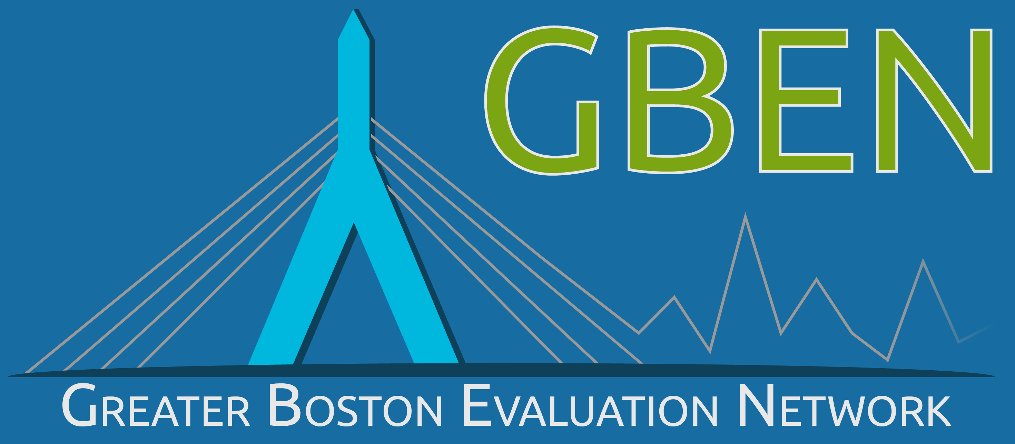

2020
YEAR IN REVIEW

Email: Admin@greaterbostoneval.org Website: greaterbostoneval.org
A Message from the GBEN Board

1

Dear Members and Friends,
Despite the challenges of COVID-19, GBEN had a very productive year. Our full 2020 Annual Report will be released in the Spring; in the meantime, we wanted to share the highlights of the past 12 months.
Our membership numbers continued to grow. And, while we sorely missed the professional and social benefits of meeting in person this year; our Programming Committee organized a slate of excellent virtual offerings. In fact, having our events remotely allowed a greater number of members and friends to participate! We were excited to partner with two other AEA affiliates for two workshop opportunities. In addition, GBEN members continued to reap the benefits of our monthly newsletter, blog posts, and website offerings.

GBEN continued on the path to build its capacity as a more diverse, equitable and inclusive organization. We established the Diversity, Equity and Inclusion (DEI) Committee as an official GBEN standing committee, with its Co-Chairs sitting on the Board. We welcome new Co-Chair Calpurnyia Roberts, who serves along with former Programming Chair Min Ma. We look forward to unveiling GBEN’s DEI plan early in 2021.
This kind of progress is impossible without our members. GBEN is grateful for your memberships and participation. Thank you for being a part of this community so that together we can elevate our evaluation practice to improve programs and services for our communities. We look forward to your continued support and engagement throughout 2021.
Sincerely,

Danelle Marable, President & The Executive Committee

Matan BenYishay, Vice President
Elizabeth W. Brown, Clerk
Eileen Marra, Treasurer

Bryan Hall, Communications Committee Chair
Kelly Washburn, Programming Committee Co-Chair
Min Ma, DEI Committee Co-Chair
Calpurnyia Roberts, DEI Committee Co-Chair

The Greater Boston Evaluation Network (GBEN) is a collective of evaluators and other professionals doing evaluation-related work in and around the Greater Boston, Massachusetts, region. We are an official local affiliate of the American Evaluation Association and a registered 501(c)3.

Our mission is to promote excellence, innovation, and equity in evaluation among professional and aspiring evaluators, and those who align their work with the discipline of evaluation in Greater Boston.

We do this through professional development, resource-sharing, and networking around evaluation approaches and best practices.

We value the inclusion of voices from diverse sectors and experience levels.

A

Our Members

2
2018
2020
2019
134 Professional Members
11 Student Members

Our Programs & Partners

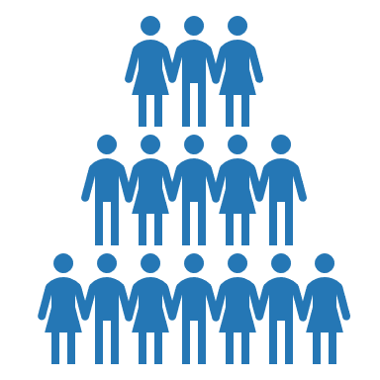
Programming Topics Included:
- Culturally Responsive Evaluation (CRE)
- Getting Started with Consulting
- Let’s Hear it for the Visuals! Infographics and Coalitions
- Evaluators as “Accidental Techies”
- Adapting Evaluations during COVID
- Qualitative Comparative Analysis
- Values in Evaluation Applied
- Trauma-informed Data Collection
- Building Evidence

9 Virtual Roundtables and
workshop events

1 virtual social networking event
about GBEN leadership
opportunities

An average of 33 attendees at each
event (ranging between 17 and 68)
63% of members attended at least
one GBEN event.
Event Partners:
- Boston College
- Evaluation Association of St. Louis (AEA Affiliate)
- Northeastern University Public Evaluation Lab
- New York Consortium of Evaluators (AEA Affiliate)

A

Communications
3

- 12 monthly newsletters
      - delivered a cumulative total of 2,073 times
      - Opened by 55% of members
- 6 blog posts

Diversity, Equity & Inclusion Initiative

- Received funding from the Barr Foundation in 2019
- Established the DEI Committee as an official GBEN standing Committee (currently 15 members-strong)
- Released an RFP and hired a consultant to assist in DEI visioning and planning
- Conducted a survey of GBEN members and friends about DEI topics, 51 people responded.
- Arranged a workshop on culturally responsive evaluation.

